GIT BRANCHING

1. First take a backup of your assignments & projects. This is required because due to incorrect GIT operation you may lose your files.
2. Create an empty directory ‘Assignments’ & cd to ‘Assignments’.
3. Create a file README.txt inside ‘Assignments’ & write few lines about the contents of ‘Assignments’ folder.
4. Commit README.txt file.
5. Now create a new branch ‘html-assignments’.

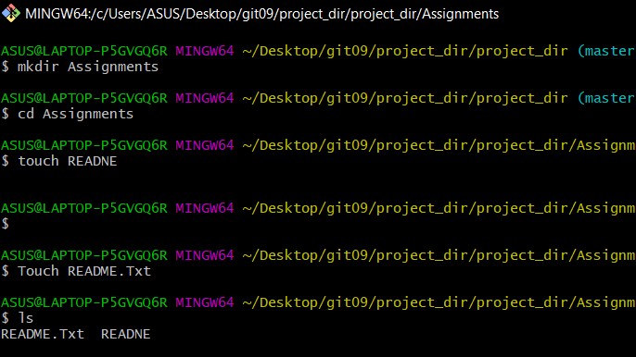

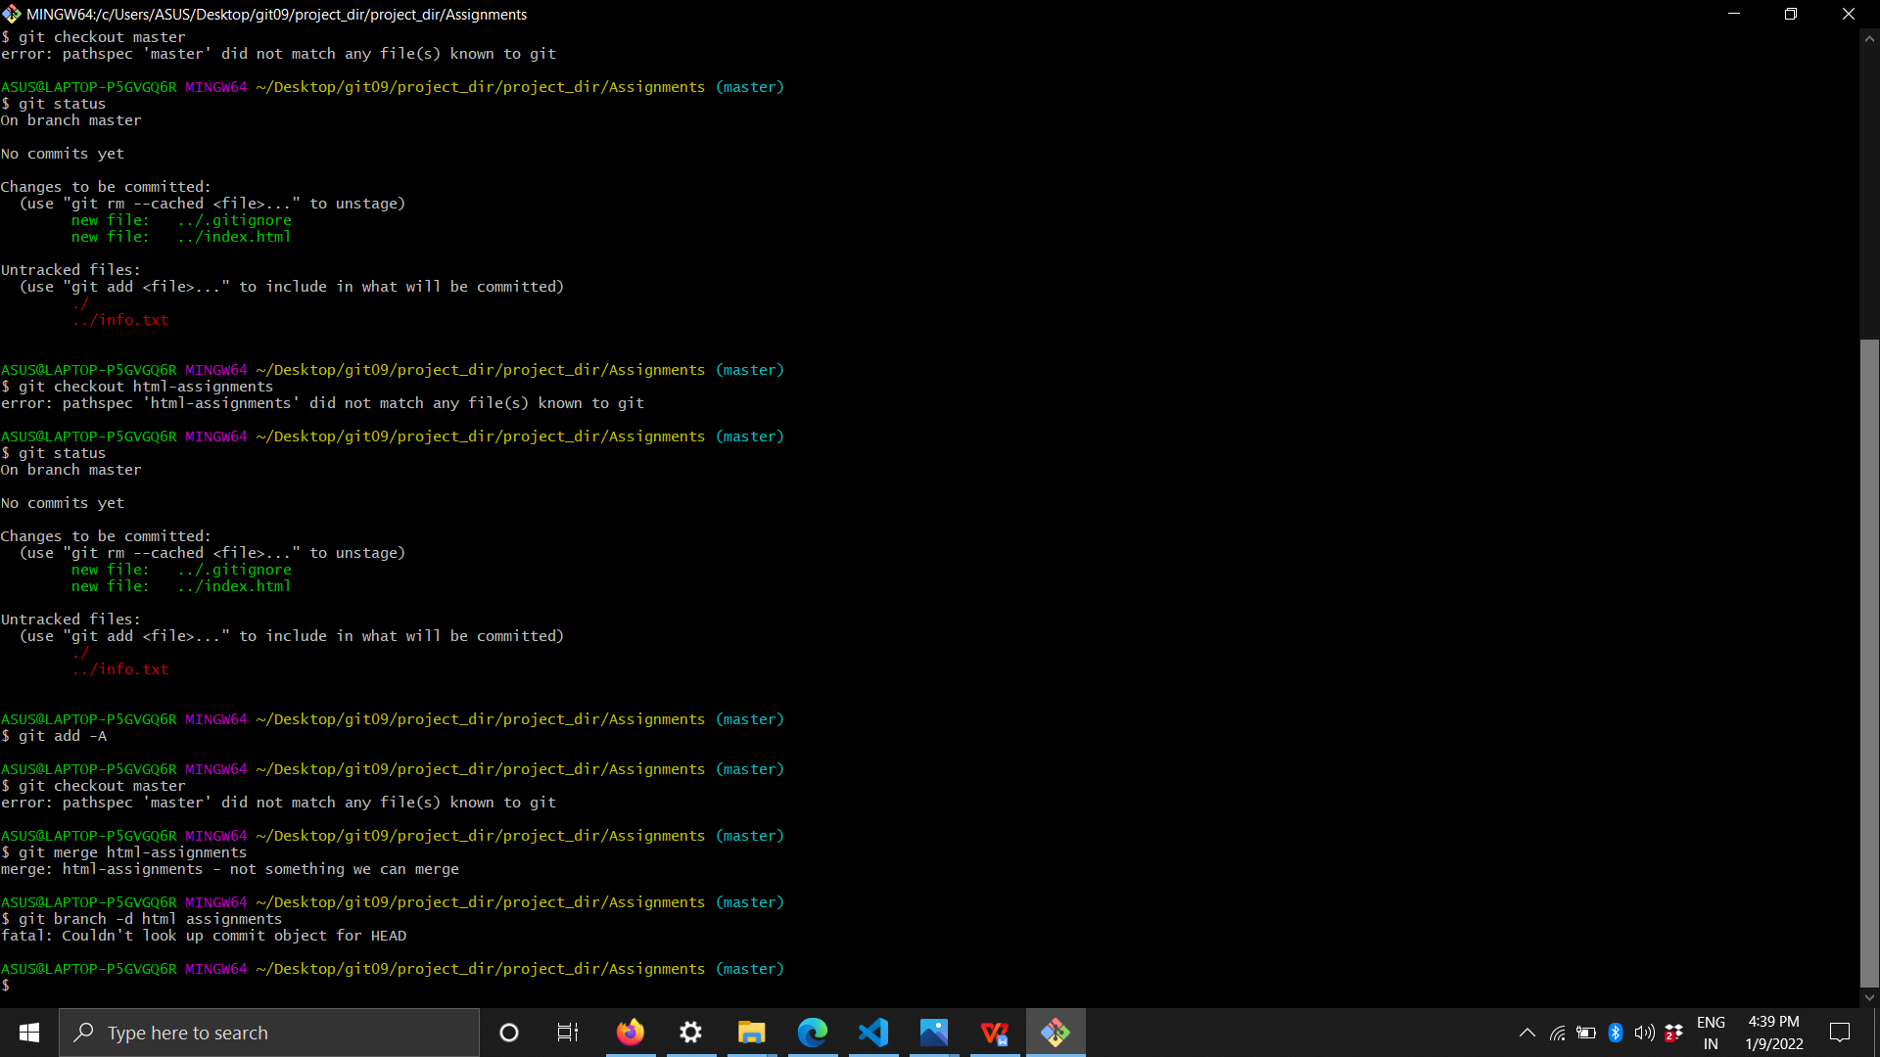

1. Switch to ‘html- assignments’ branch.
2. Copy all HTML assignments inside ‘Assignments’ folder.
3. Commit HTML assignments into ‘html-assignments’ branch.
4. Make minor changes into few files belonging to ‘html-assignments’ branch.
5. Commit those changed files

Finally delete the ‘html-assignments’ branch.

1. Switch to master branch.
2. 32. Make minor changes into README.txt file & commit those changes into master.
3. Again switch to ‘html-assignments’ branch
4. Make minor changes into few files belonging to ‘html-assignments’ branch.
5. Commit those changes.
6. Switch to master
7. Merge ‘html-assignments’ branch into master. Confirm all html assignments are shown in master.
8. Finally delete the ‘html-assignments’ branch.

